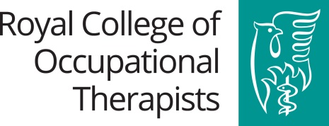
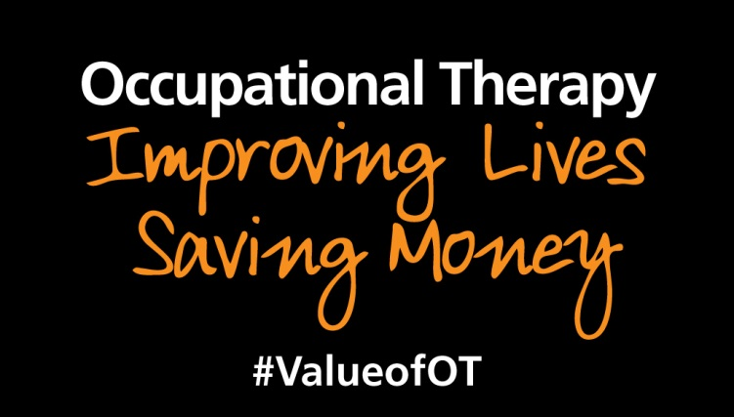

How to demonstrate the impact of occupational therapy

Name of service and location (please include country)
Description of the service:
e.g. the service purpose, profile of users, setting, integrated/multidisciplinary, seven day etc.
The challenge:
What was the service set up to address? Where was the gap in service delivery?
Actions taken: e.g. aims of service, delivery, assessments and measures used
Tell us what you/your service did and how you now deliver occupational therapy e.g. assessments, interventions and measures used. These may include:
- changes in how you work with partners and liaise with other agencies.,
- changes in how you offer access to occupational therapy,
- have repositioned the role of occupational therapy ,
- how occupational therapy is now delivered
- co-production, community assets based approach
- working with carers

Impact: e.g. Difference to service users, carers, systems delivery, other services & delivery partners
What has been the difference to service user’s experience of referral and impact from working with the service?

Have new pathways been developed, new partnerships or communities of practice formed?
Has there been a difference to the local community?

Describe the outcomes of your interventions and/or the outcomes of your service. Outcomes demonstrate changes. Outcomes may reflect improvement, maintenance or prevention of deterioration.

Proxy outcomes will include avoidable use of services for example: reduced hospital admissions and care home placements.

You may want to include results from your outcome measures - for example:
- MOHO tools (Model of Human Occupation)
- Assessments Health of the Nation Outcome Scales (HoNOS)
- EQ-5D
- Canadian Occupational Performance Measure (COPM)
- Australian Therapy Outcome Measures (AusTOMs)
- Assessment of Motor and Process Skills (AMPS)
- Goal Attainment Scale (GAS)

Measure of success:
These include:
- Improvements to service users - occupational outcomes, health and wellbeing outcomes - mental and physical health benefits, social engagement, ability to self-manage
- Value to the carer(s)
- Improvements to service delivery (quality of care outcomes)
- Costs savings/return on investment
There are different types of outcomes to be considered: Occupational outcomes, Health and Well Being outcomes and Quality of Care outcomes.

- Occupational Outcomes may capture improvements in relation to:
- The number of occupational goals achieved
- A person’s confidence and ability to continue with occupations
- Independence- reduced dependency on others to carry out occupations
- Ability to return to roles

- Health and wellbeing outcomes may capture improvements in relation to:
- Occupations the person is now able to engage in
- Ability to maintain roles
- Return or ability to stay in work
- Ability to access family, friends and communities
- Person’s perceived ability to manage their illness
- Person’s experience and ability to cope –PREMs
- Value to the carer

These are usually reported through Qualitative data but can also be captured through Quantitative data i.e.- the numbers and percentages of:
- Outcomes set by the person achieved
- People completing intervention/ reaching goals
- People discharged from the service

- Quality of Care Outcomes may capture improvements to:
- Value of the service to the person- PROMs
- Value of the service to the carer
- Communication and partnership working between services
- Improving transition from hospital to home

For managers and commissioners who invest money into a service, it is important to see what the return on that investment is, not only from the improved outcomes but also how the service can save money in the long term i.e. you need to be able to demonstrate how the service is cost effective. e.g.

- Number of bed days saved.
- Discharge from hospital or services.
- Delay/avoidance of admissions- hospital, residential care
- Reduction in number of other agencies involved
- Reduction in the number of care visits or numbers of staff involved in delivering care
e.g. reduction in the need for double handling.
- Reduction in use of emergency and crisis response services e.g. Calls to 999

Some savings may not be specifically quantifiable but still have a positive financial impact for the person or society. For example:
- Remaining or returning to work
- Reduction of reliance on benefits
- Not re-offending

Certain services are expensive but their positive impact justifies the investment e.g. services for children with complex needs. If this is the case for your service, make sure you have included
evidence of the impact on prevention and wellbeing.

Examples of Unit Costs of Health and Social Care taken from 2017 data:
Staff Costs (taking all other costs into account) | Service Costs
Occupational Therapists per working hour  NHS Community:  (mean average cost per working hour)  Band 5 £33 Band 6 £43, Band 7 £53  Community local authority:  £42 per working hour  NHS hospital based:  Band 5 £34, Band 6 £45, Band 7 £55  General Practitioner  Consultation costs:  £38 per consultation (9.22 minutes)  £27.90 per prescription  Support staff (per working hour)  Independent sector home care provided for private purchasers: £21 weekday, £23 per day-time weekend, £22 per night-time weekday, £23 per night-time weekend).  Face-to-face: £26 per hour weekday (£28 per day-time weekend, £27 per night-time weekday, £29 per night-time weekend).  Independent sector home care provided for social services: £22 per weekday, weekend and night time. Face-to-face: £26 weekday, £27 day-time weekend, £27 per night-time weekday, £27 per night-time weekend).  NHS hospital AHP support worker £24  Teaching Assistant £20 | Hospital Admission  Cost of average episode:  Elective inpatient stay £3903  Non-elective inpatient long stay £2953  Non-elective inpatient short stay £628  Elective inpatient stay children £2,905  NHS Children’s Community Services,  Average cost per one-to-one occupational therapy group session £96  Social care provision  Reablement:  Per hour of contact £45  Average cost per service user £2,187  For older people:  Private sector nursing home weekly £806  Private residential care weekly £632  Local authority residential care £1108  Local authority day care per client attendance £63  Extra Care Housing per week £490  For people with learning disabilities:  Local authority day care per client £85  Residential care home weekly £1699  Supported living weekly £963  Supported living for people with  autism and complex needs weekly £1515  (PSSRU, 2017.)
For further information on a wider range of unit costs: Personal Social Services Research Unit, 2017. Unit Costs of Health and Social Care 2017. Available at: http://www.pssru.ac.uk/project-pages/unit-costs/unit-costs-2017/
See Section 7.3 for Equipment and Adaptations, p112-113.
N.B. Always reference the source of your unit costs which may differ depending on your location in the UK.

Service Example:
Name of service and location: A&E, Urgent Care and Acute Care

Description of the service:
Occupational therapy covers A&E and Urgent Care Centre, Clinical Decisions Unit (CDU), Medical Admissions Unit (MAU) and Acute Medical Unit (AMU). The service is staffed by a Band 8 and 7, working two shifts per week, plus one weekend per month and Band 6 weekdays. Priority is given to A&E patients, then CDU followed by MAU and then AMU. The service aims to:
- provide a timely response
- minimise the number of unplanned admissions into hospital and
- signpost or refer people to services in their local community for ongoing care and support

The challenge:
People with complex needs (frailty, health, housing and social care) are either:
- not discharged once medically optimized and then at risk of a long stay in hospital
- discharged but person presents again to frontline services.

Actions taken:
Attendance by occupational therapists at daily handover in A&E and CDU and medical round for the admissions and medical unit.
- Referrals identified and cases prioritised
- Assessments to consider risk, cognition, mobility and transfers in relation to occupational performance
- Goals and outcome agreed with the patient
- Prescription and provision of equipment,
- Liaison with family and other agencies involved
- Referral for further services, such as community rapid response teams

Impact:
Multidisciplinary service offered within A&E. This has led to a wider consideration of people’s needs in terms of housing, care and community resources.

More effective risk management and transition from hospital to home due to improved communications between hospital and community services. A reduction in the number of people admitted and readmitted into hospital.
Interventions are tailored to a person’s needs and priorities. Patients are partners in the decision process. Patients are asked what they would like to happen, goals are agreed and outcomes met.

Measure of success:
Number of referrals over last 6 months = 720
Proxy outcomes: 79% discharged home and of these 24% discharged to reablement services
Quality of Care outcomes: 89% of patients felt their agreed outcomes were achieved

Costs of the service:

NHS hospital based Band 6 occupational therapist | = £43 per working hour
Based on 1 hour per patient 720 hours x £43 | = £30,960
79% of 720 referrals= 569 patients. Average costs of a non-elective inpatient stay | = £2,888
Potential cost savings in inpatient stay of 569 patients x £2,888 over 6 months | £1,643,272 – £30,960 = Total savings of £1,612,312
Average cost of the service incorporating reablement costs per service user £2,187 | £30,960 + £297,432 = £328,392  (24% of 569= 136 patients. 136 x £2,187 = £297,432)
Total savings - total costs = overall savings | £1,612,312 - £328,392 =  Overall savings of £1,283,920

