Information for the Royal College of Occupational Therapists (RCOT) Regions

RCOT members have automatic membership to their local region group based on their registered postcode. RCOT regions promote, encourage, and support the development and profile of occupational therapy within each region and provide opportunities to network with other occupational therapy practitioners within one of 13 geographical areas.

This document provides information about RCOT region committees. Essential resources for committee activity can be found on the RCOT website under Communities Resources at www.rcot.co.uk/about-us/rcot-branch-resources.

Purpose and core business of an RCOT region

Regions are run by a committee consisting of RCOT members who volunteer through annual elections and represent the interests of all members in the region.

The region committees are required to achieve the following core business each business year (1 October – 30 September):

- Meet as a committee (virtually or in person) at least 4 times a year.
- Ensure the effective financial management of the region and its budget.
- Ensure representation of the region at the Communities Forum twice a year.
- Host an Annual Review Meeting (ARM), open to all members of the region. This can be added to an event.
- Collate and create up to four e-Newsletters annually. E-bulletins can be distributed as needed throughout the year.
- Engage with members and promote the region using social media.
- Host at least one virtual or face to face networking, CPD or social event annually.
- Complete required reports, including annual business plan and budget.
- Monitor and use the region’s RCOT inbox for communicating with members and committee business.
- Keep the region’s RCOT webpage up to date.
- Engage with local universities and their occupational therapy societies.
- Support annual elections for regions and new committee members.
- Support the work of RCOT including all branches and boards.
- Adhere to all RCOT policies and governance.

All activities organised by committees must be conducted in accordance with The Royal College of Occupational Therapists Regional Committees Terms of Reference, which can be found on the RCOT Communities Resources webpage.

Membership of a region

All UK RCOT members are members of a region. Members are allocated a region based on their registered postcode.
There are 13 regions; one in Wales, three in Scotland, one in Northern Ireland and eight in England (see below).

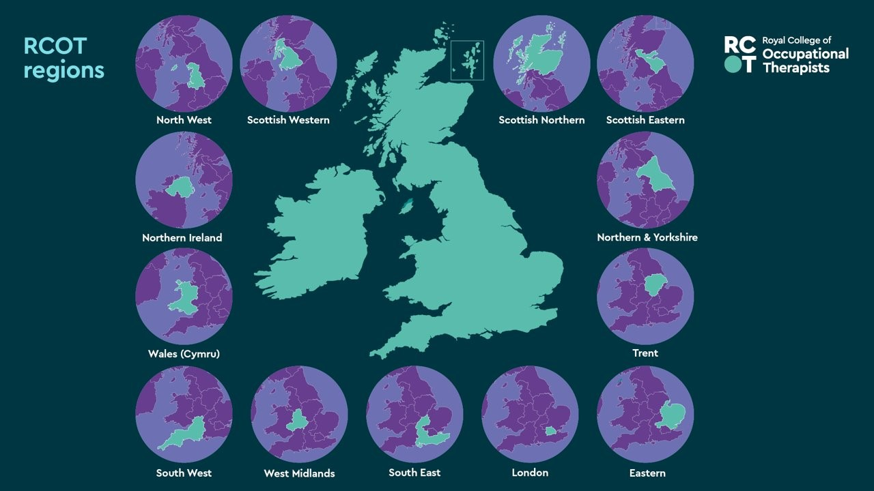
Committee member professional development and opportunities

Volunteering on a region’s committee contributes towards an individual’s continuing professional development (CPD), provides opportunities to upskill and can contribute to all pillars and levels of the RCOT Career Development Framework: Guiding principles for occupational therapy. Committee members may have the opportunity to:

- be an ambassador of the profession both internally and externally
- be part of a local and national professional community
- gain and develop a new skill set, with support, training and guidance
- contribute to developing professional knowledge, skills, research and practice of the profession
- debate and participate in discussions, networking and sharing with other occupational therapists working in the same region
- link with the Country Boards and other RCOT communities
- participate in RCOT activities, for example, RCOT Annual Conference and careers activities
- influence on behalf of RCOT and the profession.

Committee structure and roles

There are seven elected core committee members for all regions. Core committee members sit a three-year term of office and can be re-elected for a further three years. Following the completion of a second term of office, they must leave the committee for a minimum of one year before reapplying to sit on the committee again.

Each committee member will serve no longer than six consecutive years in a single post.
The term of office will run from the 1 October to 30 September.
The seven core committee roles are:

- Chair
- Vice Chair
- Treasurer
- Secretary
- Regional Communications Lead
- Member Activity Lead
- Social Media Lead.

All core committee members, including co-opted and members contributing to work for the committee, must complete a nomination form and submit it to the RCOT Communities team.
If a committee member needs to take a period of leave from the role (for example, maternity leave/sick leave), they must inform the region chair so a decision can be made by the committee about how the role/period of absence will be managed. A member from the region can be co-opted onto the committee during this time.
All changes in the committee should be sent to the RCOT Communities team.
Roles on the committee may be shared subject to the committee’s agreement, except for the chair and treasurer roles.
RCOT holds induction training for committee members. Existing committee members who sit a second term of office and have been on a committee for more than three years should complete induction training again.

Committee role descriptions

Chair

Outline | To chair the region’s committee, to have an overview of the region’s activities alongside acting as the key contact and facilitator for the region and RCOT.
Key tasks | To act as representative for the region’s committee.  To chair committee meetings and support committee members in delivering committee activities.  To encourage effective communication within the committee, meeting attendance and strive to deliver committee activities.  To oversee the committee’s finances alongside the treasurer and committee members.  To support the vice chair with the submission of the region’s annual report lead  To keep up to date, encourage, promote and support the work of RCOT.  To liaise with the RCOT Communities Manager, Engagement Officers and Communities Administrators and respond as appropriate to enquiries/information.
Skills | Leadership, organisational, communication, strategic, decision making, time management.
Support offered | One to one induction if requested.  Information, resources, committee governance.  Ongoing support from RCOT staff.

Vice Chair

Outline | To act as the link between the region and RCOT. This includes attending the Communities Forum meeting twice a year.
Key tasks | To chair the committee in the absence of the chair.  To represent the interests of the region at the Communities Forum meetings (twice yearly).  To feedback information from the Communities Forum meeting to the region’s Committee and to lead on follow up actions.  To be the main contact with local group leads, new graduates’ groups, occupational therapy societies and co-opted committee representatives.  To lead on the submission of the region’s annual report.
Skills | Communication, organisational, travel may be required, leadership, strategic.
Support offered | One to one induction if requested.  Information, resources, committee governance.  Ongoing support from RCOT staff.

Treasurer

Outline | To ensure financial affairs are compliant with RCOT governance and to act as the primary point of contact for financial matters.
Key tasks | To ensure that the region’s financial affairs are conducted in compliance with the current RCOT Branches Finance Manual.  To act as the primary point of contact regarding financial matters for the  region.  To report on the financial status of the region at each committee meeting, and to present the financial report at the Annual Review Meeting (ARM).  To ensure income and expenditure is accounted for and authorised in a timely and accurate manner.  To keep secure financial records for the current year and three prior years.  To assist any local groups to abide by the financial requirements.  To lead on preparation and submission of the region’s annual budget in July, for approval by the RCOT Head of Finance.  To oversee the funds allocated for the region’s Lifelong Learning Grants.
Skills | Organisational, budgeting and account management, communication, decision  making.
Support offered | One to one treasurer training.  Information, resources, committee governance.  Ongoing support from RCOT staff.

Secretary

Outline | To collate and circulate agenda items and information in preparation for meetings and to take and distribute minutes.
Key tasks | To take the minutes of committee meetings and Annual Review Meetings (ARM), or if unable to attend, to nominate another committee member to fulfil this role.  To circulate the minutes, via email, to all committee members and to the RCOT Communities team.  To book rooms or video conference time as necessary for committee meetings.  To ensure that all region committee contact details are up to date and sent to the RCOT Communities team.  To liaise with the RCOT Communities team to ensure appropriate information is uploaded regularly onto the region’s RCOT webpage.  To monitor the region’s inbox and respond to emails as required.
Skills | Organisational, communication, decision making, time management, IT-  including use of virtual platforms.
Support offered | Information, resources, templates and committee governance.  Ongoing support from RCOT staff.

Regional Communications Lead

Outline | To produce the region’s e-newsletters/e-bulletins with members of the committee as well as to support and encourage the writing of articles for inclusion in the e-Newsletter.
Key tasks | To lead production of a region’s e-newsletter and optional e-bulletins four times per year with support from the region’s committee.  To encourage people to write articles, throughout the year, on any topic thought appropriate for inclusion in the e-Newsletter, or for inclusion in OTnews.
Skills | Organisational, communication, strategic, decision making, writing, editing.
Support offered | Information, resources, templates, committee governance.  Ongoing support from RCOT staff.

Member Activity Lead

Outline | To lead on the region’s activities for members and be the first point of contact for RCOT.
Key tasks | To be first point of contact regarding the region’s committee activities and events for RCOT members.  To lead on developing engaging local activities that promote occupational therapy, the region and membership of RCOT.  To take the lead in engaging local groups and informing the Committee of feedback received from the membership.  To respond to activity specific email in the region’s inbox.  To liaise with RCOT regarding promotional materials for events and keep a small storage of these materials for use by members in the region.
Skills | Organisational, communication, strategic, decision making, marketing, problem solving, IT including experience of virtual platforms.
Support offered | Support organising events on request.  Information, resources, committee governance.  Ongoing support from RCOT staff.

Social Media Lead

Outline | To maintain and engage with social media accounts on behalf of the region.
Key tasks | To manage, promote and engage in the use of social media on behalf of the region in line with the Social Media Briefing.  To network on behalf of the region wherever possible using social media.  To promote and engage in OT Week activities via social media.  To promote occupational therapy as a profession, membership of RCOT and to highlight the work of the region wherever possible.  To engage with members in the region and answer queries via social media.
Skills | Digital, social media, organisational, communication, strategic, marketing.
Support offered | Information, resources, committee governance.  Ongoing support from RCOT staff.

Co-opted committee members

Co-opted committee members are welcomed onto a region’s committee to represent the membership views from categories of membership, groups of members, academic institutions, or localities. They are an essential addition to a committee and help to gain expert knowledge from representatives and develop links on behalf of the committee. The term of office for a co-opted member is one year and is reviewed on a rolling basis, as agreed with the committee and the co-opted committee member.

Co-opted members must be members of RCOT. Responsibilities for co-opted members include:

- attending and contributing to committee meetings
- updating the committee with news, issues and progress from their university, organisation, member category or local area
- contributing to planning activities including conferences, CPD and social events.

Co-opted members can hold the following positions:

Co-opted Student Member Representative

Student member representatives can be in any year of study and must attend a university located within the region. They act as the link between the university, Occupational Therapy Societies (if there is one) and the region’s committee. They strengthen the relationship between the students in the region and the university to ensure that their students are represented in the committee’s activities. They are also responsible for promoting the work and profile of the region as well as membership of RCOT at their university. They are encouraged to network with other universities and Occupational Therapy Societies within the region.

Co-opted New Graduate Representative

New graduate representatives work with committee members to ensure that the committee’s activities represent the interests of newly qualified occupational therapists and support their transition from student to professional member. To be eligible for the role of new graduate representative, the member must take up this post within one year of graduating.

Co-opted Retired Member Representative

Retired member representatives work with committee members to ensure that the committee’s activities represent retired or soon to be retired member interests alongside all other RCOT members. Retired member representatives must currently be retired or planning to retire within the next year upon joining the committee.

Co-opted Associate Member Representative

Associate member representatives work with committee members to ensure that the committee’s activities represent associate members, including occupational therapy assistants and occupational therapy staff, alongside all other RCOT members. Associate member representatives must be an associate member of RCOT.

Co-opted Higher Education Institution (HEI) Representative

Higher education intuition (HEI) representatives are a key link between the region’s committee and its local universities. They are encouraged to work with the student representatives to promote the work of the region and RCOT amongst university students and staff. They work with committee members to ensure that the committee’s activities support the university’s students and to encourage cross-working between the region and university.

Co-opted Local Group Representative

Local group representatives work with committee members to ensure that the committee’s activities take into account the needs of the local group that they represent. Local group representatives should provide opportunities for the region and the local group to support each other, and they should regularly update the region committee on local group business. For more information on the operations of local groups, please see the RCOT Local Group FAQs on the communities resources page (https://www.rcot.co.uk/about-us/rcot-branch-resources).

Co-opted Independent Practice/Third Sector Representative

Independent practice/third sector representatives work with committee members to ensure that the committee’s activities take into account the needs of members working in independent practice or in third sector. They support the region in being inclusive of members working alone or in organisations without occupational therapy colleagues or professional support.

Co-opted BAOT UNISON Steward

BAOT UNISON stewards act as the link between UNISON and the region. They provide updates on the work of UNISON and how it relates to occupational therapists within the region. They also attend the UNISON Steward Annual Conference and update the committee following this.

Co-opted Equity, Diversity and Belonging Representative

Equity, diversity and belonging (EDB) representatives work with the committee to ensure that the region’s activities are equitable and inclusive, and both encourage and celebrate diversity.

