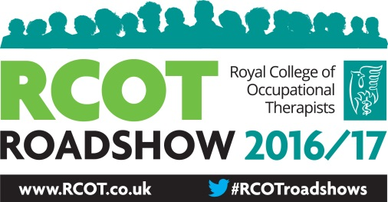

RCOT Roadshow 2016/17
Championing Occupational Therapy
Date: Saturday 16th September 2017
Time: 9.30am – 2.30pm
Venue: Showrooms, 15 Paternoster Row, Sheffield, S1 2BX
RCOT Roadshows are annual events hosted by RCOT regions for all occupational therapists, occupational therapy staff and occupational therapy students.
This session is designed to ensure occupational therapy staff feel confident and equipped to engage with the Occupational Therapy Improving Lives , Saving Money Campaign and to sign post our members to available RCOT resources to evidence the value of their service.
The roadshow will cover the key recommendations from the RCOT report Reducing the Pressure on Hospitals – the Value of Occupational Therapy and next steps for the campaign. Members will be asked to identify who they need to talk to and discuss ways of influencing locally, messages they can tailor locally and outcomes they want to achieve.
In the session we will explore how to:
- Write a patient story
- Contact and liaise with local media
- Measure and evidence the effectiveness of services
- Promote the value of occupational therapy to managers and commissioners and service users.
By the close of the roadshow participants will:
- Have knowledge of RCOT resources to evidence the value of their services
- Be able to use the RCOT campaign materials for local influencing with the commissioners, managers and service users
- Understand how to contact and work with local media
To book a place please email Olivia.lokko@rcot.co.uk with your full name and BT number
Booking closes on 6th September 2017. Places will be offered on a first come, first serve basis.
Refreshments provided on the day.

