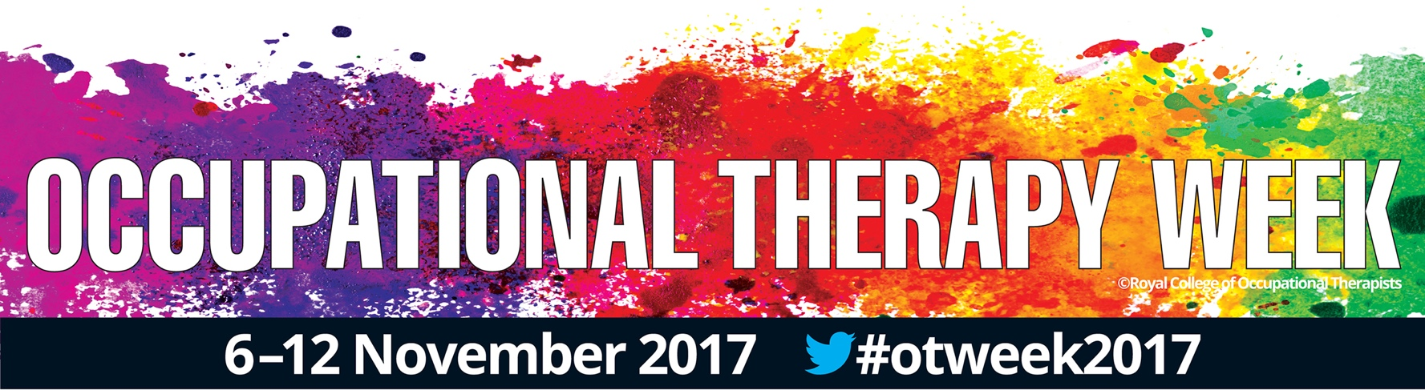

OCCUPATIONAL THERAPY WEEK COMES TO [TOWN/CITY/AREA]

A team of occupational therapists from [Service / NHS Trust / Organisation] are getting out and about to raise the profile of their profession which supports people to ‘live life their way’ despite any health or care needs they may be living with. The event is as part of this year’s Occupational Therapy Week, organised by the Royal College of Occupational Therapists (RCOT).

Taking place from 6 – 12 November the theme of Occupational Therapy Week this year is “I am an Occupational Therapist” building on the RCOT’s call for its members to be ‘loud and proud’ of the value they add to the lives of hundreds of thousands of people every week.

[Name of your organisation] is getting involved in doing just that by [details of your event including what, where, when].

Occupational Therapists have been described as the health and care system’s “secret weapon”. They are the only registered profession qualified to work across mental and physical health and in NHS and social care settings. This means that they are uniquely placed to see a whole person holistically. The team at [your details] help patients to [brief description].

Research from the Royal College of Occupational Therapists has shown that Occupational Therapists working on the frontline with ambulance services and in accident and emergency departments can reduce unnecessary admissions by up to 80%. Occupational Therapists on acute medical wards can cut stays from 9.5 days to just 1 day.

Working in social care occupational therapy-led services have been shown to provide better quality more person centred services where for every £1 spent on clients receiving it, £1.43 is saved through a reduction in the need for ongoing home care support because clients become more independent.

Quote from the chief organiser/head of your organisation. If you are struggling for inspiration, here’s one we made earlier:

Oscar Terapist, who leads the fun clinic at EventTown General Hospital said: “We love taking part in Occupational Therapy Week. That is why we are having an open day. If you think you would benefit from a service that can [WHAT YOU DO] and get you back to living life your way, pop down. It’s going to be a lot of fun.

Julia Scott, CEO at the Royal College of Occupational Therapists said: “I’m delighted that [name of your organisation] has joined the hundreds of organisations supporting Occupational Therapy Week. It is a great reflection of local community spirit.

“The [EVENT NAME] is an excellent way to promote the value of services that provide practical support to empower people to facilitate recovery and overcome barriers preventing people from doing the activities that matter to them. Occupational Therapy support can make a real difference giving people a renewed sense of purpose, opening up new horizons, and changing the way they feel about the future.”

A powerful film showing how Occupational Therapy can transform lives has been released to coincide with Occupational Therapy Week 2017. To watch it or for more information about Occupational Therapy and Occupational Therapy Week, visit: https://www.rcot.co.uk/promoting-occupational-therapy/otweek

ENDS

NOTES
- To find out more about the event, please contact [your contact details]

- To find out more about occupational therapy and the Royal College of Occupational Therapists please contact MediaOfficer@RCOT.co.uk or call 020 74505229.

