Research and Development Review  Listening Event | 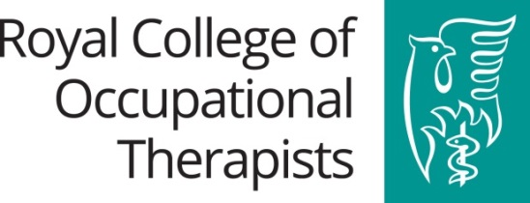
An event hosted by the Royal College of Occupational Therapists North-West Regional Group

BOOKING FORM TO ATTEND WORKSHOP
Monday 4th December 2017, 09:30 – 15:30
Redbank House, 4 St.Chad’s Street, Manchester, M88QA

AIM: This event is primarily focussed on engaging RCOT members in discussions shaping and informing the RCOT Research and Development Review, the outcome of which will be a revised RCOT Vision, Strategy and Action Plan for Research and Development. In recognition of, and to maximise the usefulness of the time given up by members to do so, we are also offering a free CPD workshop in the morning and networking opportunities over lunch.

Please note this free event is for RCOT members only.
Places are limited (maximum of 45) and will be allocated on a first come first served basis so please book early to avoid disappointment. Confirmation of a place will be confirmed via email.

Please complete and return this form to: angie.brown@rcot.co.uk Tel: 020 7450 2369

Title:
First name:
Surname:
Address (including postcode)
Job title:
Organisation:
RCOT Membership Number:
Email:
Telephone (daytime) / Mobile:
Special dietary requirements:
Special needs / accessibility
Please indicate which elements of the day you will be attending (tick ONE option below):
The full day
09:30 – 15:30
Lunch & the R&D Review Listening Event
12:00 – 15:30
The R&D Review Listening Event only
13:00 – 15:30

