Research and Development Review  Listening Event | 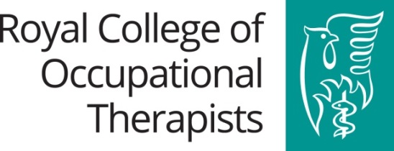
An event hosted by the School of Health Sciences, University of Ulster

BOOKING FORM TO ATTEND WORKSHOP
Friday 10th November 2017, 09:30 – 13:30
School of Health Sciences, Jordanstown Campus, University of Ulster, BT37 0QB

AIM: This event is primarily focussed on engaging RCOT members in discussions shaping and informing the RCOT Research and Development Review, the outcome of which will be a revised RCOT Vision, Strategy and Action Plan for Research and Development. In recognition of the time given up by members to do so, we are also offering networking opportunities over lunch.

Please note this free event is for RCOT members only.
Places are limited (maximum of 70) and will be allocated on a first come first served basis so please book early to avoid disappointment. Confirmation of a place will be confirmed via email.

Please complete and return this form to: angie.brown@rcot.co.uk Tel: 020 7450 2369

Title:
First name:
Surname:
Address (including postcode)
Job title:
Organisation:
RCOT Membership Number:
Email:
Telephone (daytime) / Mobile:
Special dietary requirements:
Special needs / accessibility
Please indicate which elements of the day you will be attending (tick ONE option below):
The R&D Review Listening Event & lunch
09:30 – 13:30
The R&D Review Listening Event only
09:30 – 12:30

