NIHR ICAP Awards: Maximising your success | 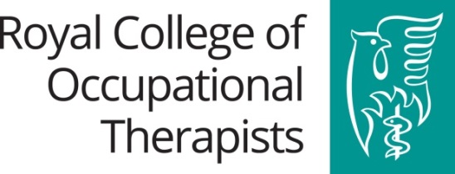
An event hosted by the Royal College of Occupational Therapists

BOOKING FORM TO ATTEND WORKSHOP

Tuesday 16th January 2018

Royal College of Occupational Therapists
106-114 Borough High Street, London SE1 1LB

Workshop aim: to support occupational therapists in: ‘developing and finalising/polishing’ their application for a National Institute for Health Research Integrated Clinical Academic Pathway Award at Clinical Doctoral Fellowship or Clinical / Senior Clinical Lectureship level.

Delegates must have made a commitment to apply for an NIHR Clinical Doctoral Fellowship or Clinical / Senior Clinical Lectureships in 2018 (rounds open March 2018). Preparing an application can take 12-18 months and, as such, delegates will need to have done a lot of work prior to the workshop, and be ready to bring along a well-developed draft of their application.

Please note this free event is for RCOT members only.
Places are limited (maximum of 12) and will be allocated on a first come first served basis so please book early to avoid disappointment. Confirmation of a place will be confirmed via email.

Please complete and return this form to: lesley.gleaves@cot.co.uk Tel: 020 7450 2323

Title:
First name:
Surname:
Address (including postcode)
Job title:
Organisation:
RCOT Membership Number:
Email:
Telephone (daytime) / Mobile:
Special dietary requirements:
Special needs / accessibility

Please indicate below the NIHR Award level you are applying for in 2018:

Clinical Doctoral Fellowship |  |  | Clinical Lectureship |  |  | Senior Clinical Lectureship

