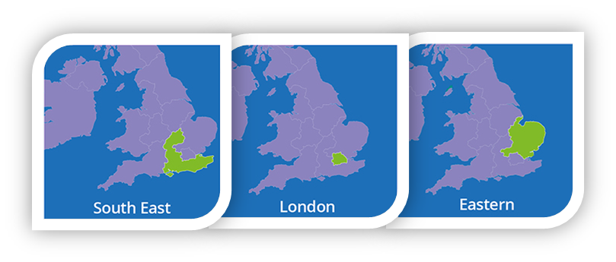



* Have an insight into how the profession is evolving and how occupational therapists are contributing to the change in health and social care.
* Be aware of the need for resilience and leadership skills within practice.
* Understand how everyday technology can help to enable care.
* Find out about innovative practice with the Eastern, London and South East Regions.
* Find out how the RCOT can support and how to interact and engage with your local Region.
* Network with occupational therapists.

By attending this event will have the opportunity to:

SAVE THE DATE! MORE DETAILS COMING SOON!

**Occupational Therapists: Future Innovators**

A joint event hosted by the  
Royal College of Occupational Therapists   
Eastern, London and South East Regions

Wednesday 5th September 2018

9am - 4.15pm