[](http://www.google.co.uk/url?sa=i&rct=j&q=&esrc=s&source=images&cd=&cad=rja&uact=8&ved=0ahUKEwiU4fbb6LLTAhUBnxQKHRyBBOsQjRwIBw&url=http://www.jcmseating.co.uk/&psig=AFQjCNHDae8ClNRcpgG7DG67ZS83DBkWYQ&ust=1492770099648448)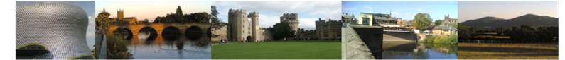 [](http://phoenix/phoenix/logos/images/RCOT-2017/RCOT-WestMidlandsRegion.jpg)

**The RCOT West Midlands Region are hosting an informal dinner and networking event on the evening of 19 June 2017. A chance to meet and network with RCOT members, RCOT volunteers and relax after the first day of the RCOT Annual Conference!**

**This dinner is open to all RCOT members and students across the UK.**

**The Dinner is due to start at 7pm but we would ask if members could arrive at least 10 minutes early. We aim to finish in time to head over to the RCOT 2017 Conference Party starting at 8.30pm.**

**Complementary drinks provided by JCM!**

**For further information please contact:**

**cot.west.midlands@cot.co.uk**

**Venue: Pizza Express, The Waters Edge, Brindley Place,**

**Birmingham, B1 2HL**

**Date: Monday 19th June**

**Time: 7pm**

**Booking is required. Please visit :** **http//www.eventbrite.co.uk/e/cot-fringe-event-at-pizza-express-tickets-33655159488**

#WMOT

West Midlands Region

Hosted

Dinner and Networking