Facilitator guide

RCOT 2022 Casson Memorial Lecture

Optimising performance, clinical and economic outcomes in occupational therapy service delivery

Thank you for being the group facilitator for the toolkit event RCOT 2022 Casson Memorial Lecture.

Your role is to facilitate discussions and encourage participants to think critically to enrich the debate. You do not need previous knowledge of the topic. You can participate in all the group activities. You just need to bring your interest and enthusiasm to the room!

Preparing for the event
To host a RCOT 2022 Elizabeth Casson Memorial Lecture event you will need:

- A room or event hosting platform such as Zoom or Teams with the capacity to welcome the number of participants you expect

- Access to the internet

- A screen to play the lecture if you are meeting face to face

- The link to the lecture (this will be provided as soon as available)

If you feel you need further guidance, please contact Prof.Dev@rcot.co.uk

Facilitating the event

Introduction
(Takes about ten minutes)

- Welcome the participants.
- Recap on the lecture topic and the lecturer. To help you, here is some background information about the lecture topic

The rise in health and social care costs has prompted a critical look at the way health and social care services for children and adult are managed and delivered. There has been a gradual but significant change in the demands for evaluating the outcomes of services.

Where once only outcome data related to service performance were required, now evidence of clinical effectiveness and cost-effectiveness is demanded. When evaluating the quality of service delivery, it is important to conceptualise outcomes related to the service efficiency (performance outcomes), service effectiveness (clinical outcomes), and cost-effectiveness (economic outcomes).

In this lecture, Dr Chu will focus on the interdependent relationship between performance, clinical and economic outcomes in service delivery which is underpinned by strong leadership, the use of various service improvement strategies and collaborative research between managers, clinicians, researchers and health economists. Service improvement strategies based on practice-based and research-based evidence will be suggested to optimise performance, clinical and economic outcomes. Occupational therapists should adopt these service improvement strategies and conduct clinical researches and economic evaluations to develop an efficient, effective and cost-effective service which can meet the client’s needs by using allocated resources and is value for money from a commissioning perspective.

- Review the sequence of activities.
- Preview the questions on pages 3-4 of the toolkit, that the participants will be discussing after the film. Suggest participants keep the questions in front of them as they watch.
- Invite people to take notes as they listen if they want.
- All the timings are guidelines. Use your judgement to decide if the group needs more or less time for each activity.

RCOT 2022 Elizabeth Casson Memorial Lecture screening
(Takes about 1 hour 15 minutes. Lecture starts at 6.30pm)

https://www.rcot.co.uk/2022-elizabeth-casson-memorial-lecture

NB: a link to the transcript will be published when available.

Individual initial refection
(About 15 minutes)

You can be flexible with the time as people gather their thoughts. Keep an eye on time so it does not overrun.

Paired discussion
(About 15 minutes)

Remind participants that:

- There are no right or wrong answers to the questions.

- The questions help participants consolidate their learning, spark discussion and expand their understanding of the lecture.

Group discussion
(About 25 minutes)

Be prepared to start the discussion by feeding back on your own pair summary. Depending on group size, warn people they have a time limit to allow everyone to speak. Keep people to time, as it is important that each pair has a chance to feed back to the group.

If you are hosting the event online, considering using a chat box function or other interactive tool to enable people to engage flexibly in the discussion. Consider asking a volunteer beforehand to get the online chat going. You might also want to ask someone to be a co-facilitator by keeping an eye of the chat function and raising any pertinent points or questions as it can be tricky to keep up with the chat sometimes! Make notes on pair summaries and keep an eye on the chat for key themes.

Once all pairs have fed back, be prepared to start the group discussion by summarising themes, drawing out key points and asking people what they think, or inviting a chat contributor to share verbally what they wrote.

If the group moves to an open-ended discussion rather than waiting to share all pair summaries, this can be encouraged. Make sure, though, that each pair has had the opportunity to feed back on their summaries if they want to.

Final individual reflection
(About five minutes)

Make sure you give yourself time for this activity too.

Thank you and close
(About five minutes)

- Thank participants for their time.

- Remind them to revisit this resource in the next few days and complete the Follow up reflection and application.

- Invite participants to send their feedback to RCOT.

Feedback
Your views are important to us! Please send us your feedback about this resource so that we can make improvements for future participants.

Email your suggestions, or any issues to Prof.Dev@rcot.co.uk.

Post-event activity
As soon as possible after the course, complete the facilitation reflection on the next page. Then complete your course facilitator certificate. File these pages in your CPD portfolio.

Facilitation reflection
2022 RCOT Casson Memorial Lecture
Optimising performance, clinical and economic outcomes in occupational therapy service delivery

Your name | Click or tap here to enter text.
Date of event | Click or tap here to enter text.

- Did you have concerns about facilitating the event before you started? How realistic were these in retrospect?
Click or tap here to enter text.

- Consider what went well. What were the elements that made these aspects work? If you were to facilitate again, how would you make sure you include these elements?
Click or tap here to enter text.

- Review what you would do differently next time. What do you want to change and why? If you were to facilitate again, what would you put in place to make this happen?
Click or tap here to enter text.

- Do you have any unanswered questions about facilitating the learning of others? Who could you discuss these questions with?
Click or tap here to enter text.

- Record your reflective learning points on facilitating the learning of others. If you have more than three, add them on the back of the page.
Click or tap here to enter text.

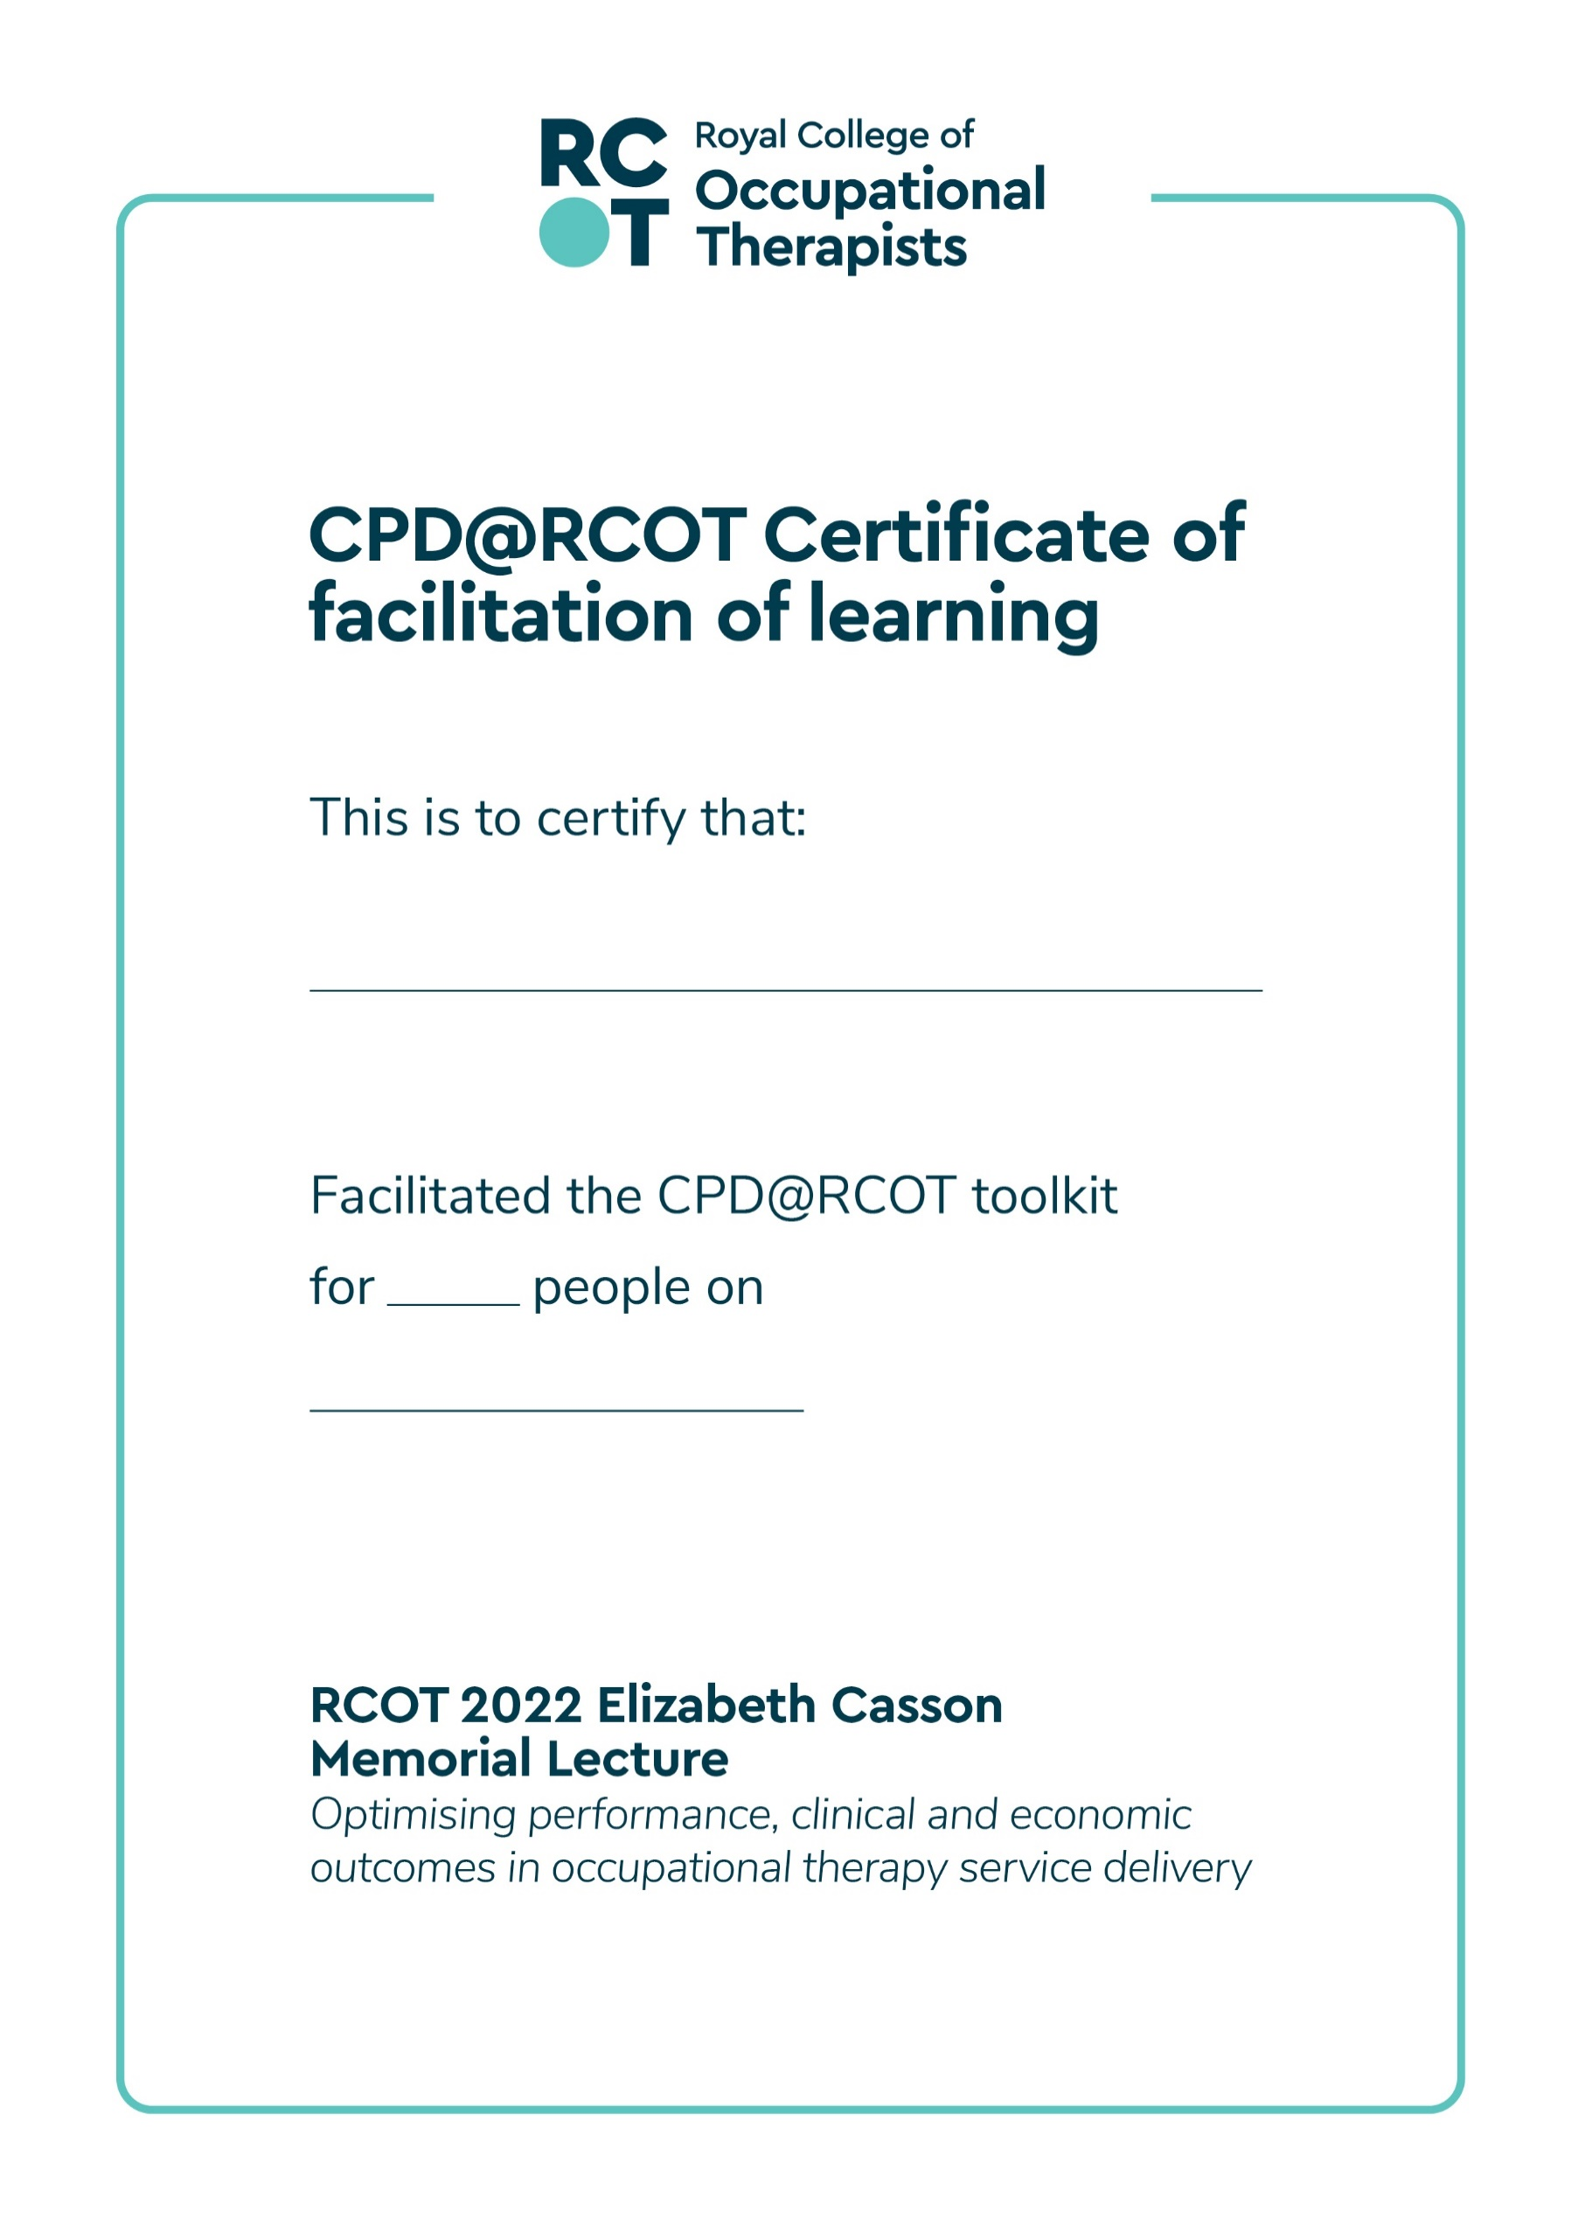
Add the date
XX
Add your name

