OT Week 2025 resource guide

A quick guide to the different types of resources and how you can use them.

# Banners – for email and elsewhere

There are three slightly different designed available. Add these to the bottom of your emails or other digital communications to show your support for OT Week and help spread the message.

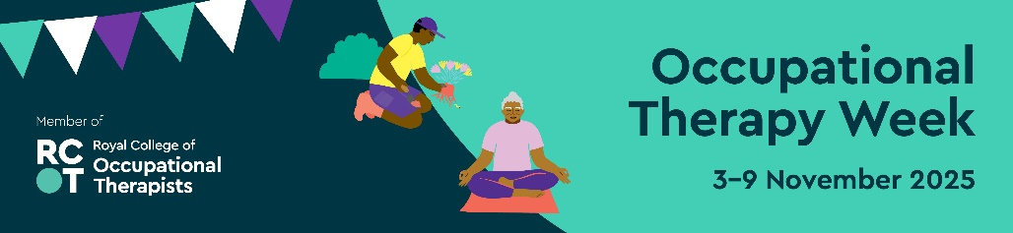

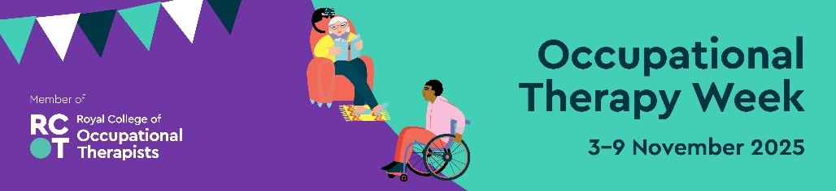

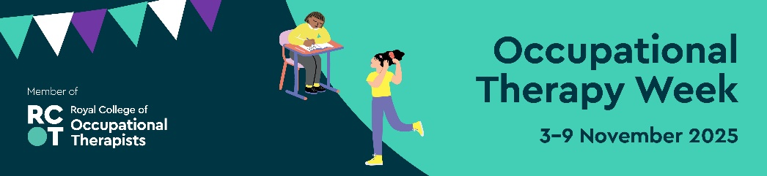

# Graphics – for social media and elsewhere

Available in two formats: square (ideal for standard posts) and portrait (perfect for stories). These are primarily for social media but could be used elsewhere.

The portrait version also comes as an editable interactive PDF – add your own text, save it as a JPG and upload it to your social media channels. There is also a portrait version that you can print and edit.

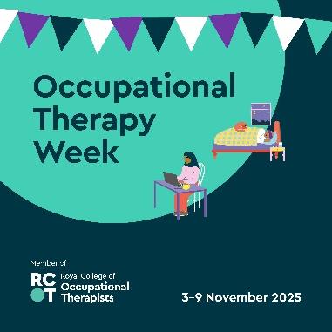

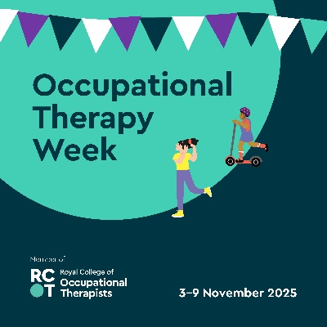

# Posters

Use the posters to promote your local activities.

Available in both portrait and landscape formats. There are two editable options: a print-and-write version for handwritten messages and an editable PDF where you can type directly into the file before printing and sharing as a digital poster.

# Virtual meeting backgrounds

Use these in virtual meetings where you want to promote OT Week.

There is a light and dark version to suit your setup and help you represent OT Week wherever you are.

# Bunting

A fun way to decorate your space for OT Week! While it might not be for everyone, many members enjoy using it for events, displays or to brighten up their workspaces.

The first page of the PDF is a step-by-step guide. The second page is the bunting – print it as many times as you need. They can be printed in black and white or colour.

