Audit form: Occupational therapy and play – practice guideline

Audit Form
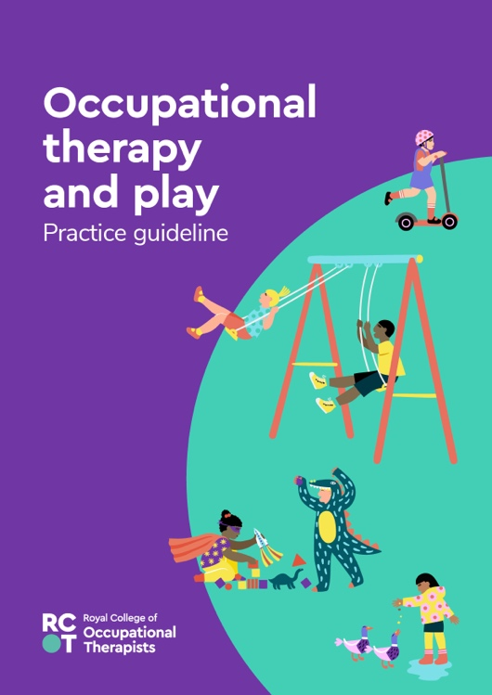
This audit tool is to be used with the evidence-based practice guideline Occupational therapy and play (RCOT 2023). You can use this tool to audit your own practice or as a part of a team delivering services to children and young people aged 0-18 years old.

The guideline recommendations should complement your clinical expertise and be interpreted with your specific context and the people who access your services in mind.

When auditing practice, you should consider the recommendations alongside the contextual information in the full guideline. This includes details about the strength and quality of each recommendation.

The full practice guideline together with implementation resources can be found on our website: https://www.rcot.co.uk/practice-resources/rcot-practice-guidelines

Reference
Royal College of Occupational Therapists (2023) Occupational therapy and play. London: RCOT.

Please ensure you save this document to your computer otherwise your changes will be lost.

Date of audit |  | Auditor |  | Role
Location |  |  | Review due date

Recommendations

Goals and outcomes recommendations |  | What is your current practice? How do you evidence this? | Comments  Actions to be taken by whom and by when
 | It is recommended that play participation is recognised as an important goal and outcome of occupational therapy for children and young people.
 | It is recommended that occupational therapists elicit the child and young person’s perspective when play participation is identified as a therapy goal or outcome.
 | It is recommended that occupational therapists consider the influence of adults’ perspectives regarding children and young people’s play participation when setting and evaluating intervention goals.
 | It is recommended that occupational therapists consider the influence of the social context of play on children and young people’s play participation when setting and evaluating intervention goals.

Assessment recommendations |  | What is your current practice? How do you evidence this? | Comments  Actions to be taken by whom and by when
 | If using a standardised assessment of play, it is recommended that occupational therapists consider the psychometric properties of the measure and their suitability to the clinical presentation and cultural context of the child.
 | When assessing participation in play of 0-5 year olds, it is recommended that occupational therapists consider both the child’s attendance (frequency of taking part) as well as the child’s involvement (experience of taking part) in play.
 | When assessing play, it is recommended that occupational therapists consider the impact of the physical environment (wheelchair use, play items and equipment) and the social environment (other people) on participation in play.

Intervention recommendations |  | What is your current practice? How do you evidence this? | Comments  Actions to be taken by whom and by when
 | For children with attention deficit hyperactivity disorder (ADHD), it is recommended that occupational therapists consider structured interventions with peer-to-peer interactions to improve social play skills where social play is the goal of therapy.
 | For children with autism spectrum disorder (ASD), it is recommended that interventions using imitation and/or modelling interventions can benefit play.
 | For hospitalised children, it is recommended that occupational therapists promote play opportunities to reduce the stress of being in hospital.
 | For children with intellectual impairments, developmental delays, and learning disabilities, it is recommended that occupational therapists promote positive mental health outcomes through activity-based interventions including play activities.
 | For children with a specific learning difficulty, it is recommended that occupational therapists consider group therapy-led peer play activities including practice play, symbolic play and games with rules to improve executive function skills and behaviour regulation.
 | For children and young people with, and at risk of, poor mental health, it is recommended that occupational therapists use play-based interventions, particularly to increase social participation.
 | It is recommended that occupational therapists consider the use of gaming technology, which is recognised as a meaningful occupation for children and young people, across a range of settings to develop performance skills such as motor skills, perception of motor ability and sensorimotor functioning.

Best practice |  | What is your current practice? How do you evidence this? | Comments  Actions to be taken by whom and by when
 | To enable play for children with a motor impairment, it is suggested that potentially modifiable factors across body function/structure, activity, environmental and personal factors are observed during assessment.

