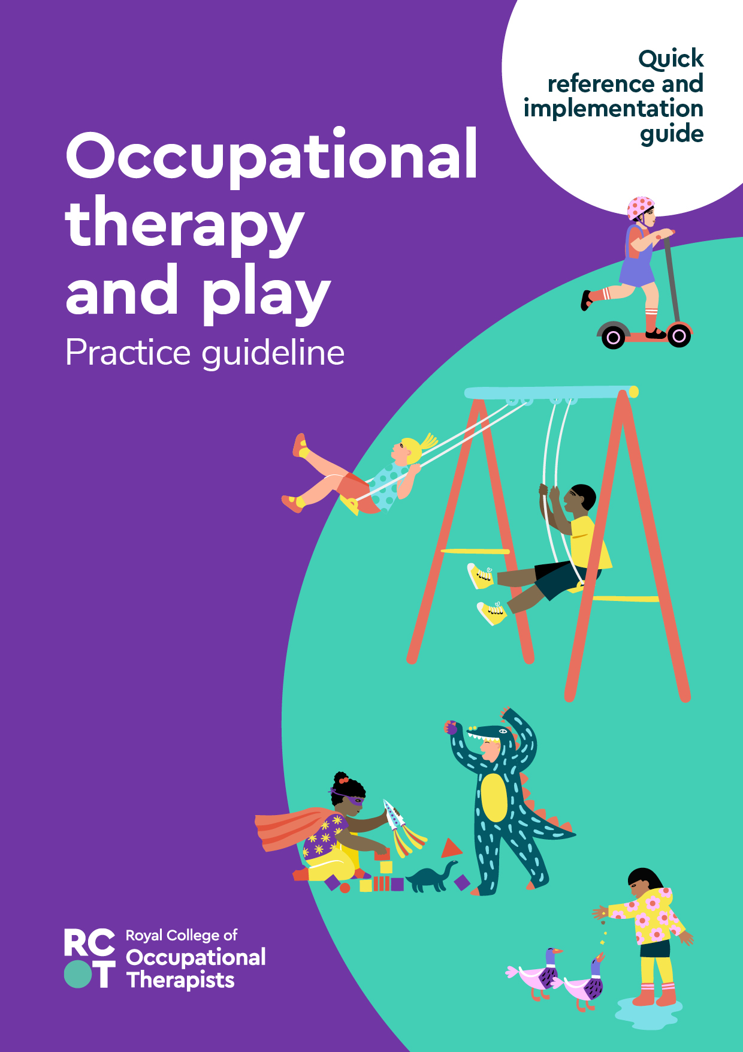
Quick reference and implementation guide

This guide provides a summary of the recommendations in our practice guideline Occupational therapy and play. Additionally, this resource gives tips for incorporating the guideline’s recommendations into occupational therapy practice.
The full practice guideline together with implementation resources can be found on our website:
https://www.rcot.co.uk/practice-resources/rcot-practice-guidelines

- Introduction
The aim of this guideline is to provide evidence-based recommendations for the use of play by occupational therapists working with children and young people aged 0-18 years old in the UK. It can support therapists in the evidence-based use of play in occupational therapy assessment and intervention, and to evaluate play participation as a meaningful goal or outcome for the child or young person. Occupational therapists will need to consider the recommendations in the context of their own practice.
Because the guideline is based on evidence, it does not cover all aspects of occupational therapy and play. It is beyond the scope of this guideline to specify models for occupational therapy services or provide recommendations for specific assessment tools or interventions.

- Play and the occupational therapy role

The primary and unique goal of occupational therapy is to enable participation in meaningful occupations, and play is a primary occupation of childhood (World Federation of Occupational Therapists 2012, RCOT 2021).

There are different definitions of play (Kuhaneck and Spitzer 2022). In this guideline, play is defined according to the Fourth Edition of the Occupational Therapy Practice Framework (OTPF4), as:

...activities that are intrinsically motivated, internally controlled, and freely chosen and that may include the suspension of reality (for example, fantasy; Skard and Bundy 2008), exploration, humour, risk-taking, contests, and celebrations (Eberle 2014, Sutton-Smith 2009). Play is a complex and multidimensional phenomenon that is shaped by sociocultural factors (Lynch et al 2016).

(American Occupational Therapy Association 2020, p34).
Children’s play develops and changes over time; in the early years sensorimotor and exploratory play predominate, with functional, constructive play and social play developing over the years. They learn to play with other children for longer periods and in larger groups and develop the ability to participate in games with increasingly complex rules. Occupational therapists need to understand the development of play occupations that children and young people typically engage in across developmental stages to facilitate appropriate play development and opportunities.
Occupational therapists promote and enable children and young people to participate in play for its own sake as a meaningful occupation and to facilitate development and learning. Occupational therapists work to ensure there is occupational balance between activities of daily living, instrumental activities of daily living, health management, rest and sleep, education, work, social participation, leisure and play (American Occupational Therapy Association 2020).

- Guideline recommendations and evidence overview
The guideline recommendations are presented in three categories that correspond to stages of the occupational therapy process: goals and outcomes, assessment and intervention.

The evidence from the 34 studies used to develop the recommendations and best practice suggestion is summarised in the guideline document (Section 5), and in evidence tables (Practice guideline supplement). Forty-seven percent of the evidence underpinning the recommendations was assessed as being high (Grade A), with 29% as moderate (Grade B) quality studies. A further 24% of the evidence was graded as low (C). The strength of a recommendation is shown in the guideline with the number one or two, and then an alphabetical grade to reflect the quality of the evidence (e.g. 1A – strong recommendation, high quality evidence). All 14 recommendations are considered strong, and the best practice suggestion is considered conditional.

The recommendations must be considered along with the contextual information and guideline development methodology described in the practice guideline document, together with current versions of professional practice documents, of which knowledge and adherence is assumed.

Goals and outcomes recommendations
Recommendation and supporting evidence | Strength
- It is recommended that play participation is recognised as an important goal and outcome of occupational therapy for children and young people.  (Schaaf et al 2018 [A]; Kuhaneck et al 2020 [A]; Ramugondo et al 2018 [B]; Jasem et al 2020 [B]; Moore and Lynch 2018 [C]) | 1A
- It is recommended that occupational therapists elicit the child and young person’s perspective when play participation is identified as a therapy goal or outcome.  (Rousseau-Harrison and Rochette 2013 [A]) | 1A
- It is recommended that occupational therapists consider the influence of adults’ perspectives regarding children and young people’s play participation when setting and evaluating intervention goals.  (Engelen et al 2013 [A]; Crawford et al 2014 [B]; Sterman et al 2016 [B]; Jasem and Delport 2019 [B]; Sterman et al 2019 [B]; Coussens et al 2020 [B]; Graham et al 2015 [C]; Román-Oyola et al 2018 [C]) | 1A
- It is recommended that occupational therapists consider the influence of the social context of play on children and young people’s play participation when setting and evaluating intervention goals.  (Kent et al 2021 [A]; Wilkes-Gillan et al 2016 [A]; Moore and Lynch 2015 [B]; Stagnitti et al 2012 [C]) | 1A

Assessment recommendations
Recommendation and supporting evidence | Strength
- If using a standardised assessment of play, it is recommended that occupational therapists consider the psychometric properties of the measure and their suitability to the clinical presentation and cultural context of the child.  (Romli and Wan Yunus 2020 [A]) | 1A
- When assessing participation in play of 0-5 year olds, it is recommended that occupational therapists consider both the child’s attendance (frequency of taking part) as well as the child’s involvement (experience of taking part) in play.  (Mobbs et al 2021 [B]) | 1B
- When assessing play, it is recommended that occupational therapists consider the impact of the physical environment (wheelchair use, play items and equipment) and the social environment (other people) on participation in play.  (Engelen et al 2013 [A]; Rousseau-Harrison and Rochette 2013 [A]; Guerette et al 2013 [C]); Sonday and Gretschel 2016 [C]) | 1A

Intervention recommendations
Interventions to support participation in play
Recommendation and supporting evidence | Strength
- For children with attention deficit hyperactivity disorder (ADHD), it is recommended that occupational therapists consider structured interventions with peer-to-peer interactions to improve social play skills where social play is the goal of therapy.  (Wilkes-Gillan et al 2016 [A]) | 1A
- For children with autism spectrum disorder (ASD), it is recommended that interventions using imitation and/or modelling interventions can benefit play.  (Kuhaneck et al 2019 [A]) | 1A
Interventions that use play to cope with life situations
- For hospitalised children, it is recommended that occupational therapists promote play opportunities to reduce the stress of being in hospital.  (Potasz et al 2013 [A]; Mohammadi et al 2021 [A]) | 1A
Interventions which use play to promote performance skills
- For children with intellectual impairments, developmental delays, and learning disabilities, it is recommended that occupational therapists promote positive mental health outcomes through activity-based interventions including play activities.  (Arbesman et al 2013 [A]) | 1A
- For children with a specific learning difficulty, it is recommended that occupational therapists consider group therapy-led peer play activities including practice play, symbolic play and games with rules to improve executive function skills and behaviour regulation.  (Karamali Esmaili et al 2019 [A]) | 1A
- For children and young people with, and at risk of, poor mental health, it is recommended that occupational therapists use play-based interventions, particularly to increase social participation.  (Cahill et al 2020 [A]) | 1A
It is recommended that occupational therapists consider the use of gaming technology, which is recognised as a meaningful occupation for children and young people, across a range of settings to develop performance skills such as motor skills, perception of motor ability and sensorimotor functioning.  (Wuang et al 2011 [A]; Salem et al 2012 [A]; Hammond et al 2014 [A]; Bonney et al 2017 [A]; Axford et al 2018 [C]) | 1A

Best practice suggestion
Where the evidence is still emerging and so the risks and benefits are more closely balanced, or there is uncertainty in the values and preferences of people who are likely to access services, a best practice suggestion rather than a recommendation for practice can be developed. Suggestions have a strength of ‘2’ (conditional).

Best practice suggestion
Suggestion and supporting evidence | Strength
- To enable play for children with a motor impairment, it is suggested that potentially modifiable factors across body function/structure, activity, environmental and personal factors are observed during assessment.  (Kolehmainen et al 2015 [B]; Stanton-Chapman et al 2018 [C]) | 2B

It is recommended that occupational therapists use the audit tool that is available to support this guideline to audit their practice against the above recommendations.

- Guideline implementation

There are additional implementation resources available to help with implementation in practice, including a continuing professional development (CPD) resource and an audit tool. Some key tips to consider for implementation are outlined in the table below.

Key tips
- Look for opportunities to promote the practice guideline with colleagues and multidisciplinary team members: include on the agenda of relevant meetings.
- Present and discuss the evidence-based recommendations with colleagues – preferably with the multidisciplinary team. A CPD PowerPoint resource is available with information already prepared and which can be tailored for your use.
- Use the guideline audit form to benchmark your service/practice and assist in identifying actions to progress implementation of recommendations. The audit form is available to download and kick-start an action plan.
- Gather evidence of outcomes using standardised assessments and measures. Visit: https://www.rcot.co.uk/practice-resources/occupational-therapy-topics/assessments-and-outcome-measures
- Use the guideline evidence and recommendations to support the case for occupational therapy as part of your business planning and commissioning activities.
- Write an implementation case study to demonstrate how your service has translated the guideline recommendations into the workplace. Provide supporting performance/outcome data and feedback from people who access services to demonstrate the difference you are making to the quality of services, cost-effectiveness and people who access services. Visit our Innovation Hub to see if you could submit your journey.
To access the implementation tools visit:
https://www.rcot.co.uk/practice-resources/rcot-practice-guidelines

- Evidence References

The full reference list for the evidence supporting the 14 recommendations and best practice suggestion, together with the full evidence tables, can be found in the Occupational therapy and play practice guideline supplement: Appendix 2 Evidence tables.
The supplement is available at: https://www.rcot.co.uk/practice-resources/rcot-practice-guidelines

- References

American Occupational Therapy Association (2020) Occupational therapy practice framework: domain and process: fourth edition. American Journal of Occupational Therapy, 74(Suppl. 2), 7412410010p1–7412410010p87.

Eberle SG (2014) The elements of play: toward a philosophy and a definition of play. [Online]. American Journal of Play, 6(2), 214–233. Available at: https://www.museumofplay.org/app/uploads/2022/01/6-2-article-elements-of-play.pdf
Kuhaneck H, Spitzer SL (2022) Making play just right: unleashing the power of play in occupational therapy. Burlington, MA: Jones & Bartlett Learning.
Lynch H, Hayes N, Ryan S (2016) Exploring socio-cultural influences on infant play occupations in Irish home environments. Journal of Occupational Science, 23(3), 352–369.
Royal College of Occupational Therapists (2021) Professional standards for occupational therapy practice, conduct and ethics. London: RCOT. Available at: https://www.rcot.co.uk/publications/professional-standards-occupational-therapy-practice-conduct-and-ethics
Skard G, Bundy A (2008) Test of playfulness. In: LD Parham, LS Fazio, eds. Play in occupational therapy for children. 2nd ed. St. Louis, MO: Mosby. 71-93.
Sutton-Smith B (2009) The ambiguity of play. Cambridge, MA: Harvard University Press.

World Federation of Occupational Therapists (2012) Definitions of occupational therapy from member organisations. 2018 revision. [s.l]: WFOT. Available at: https://wfot.org/resources/definitions-of-occupational-therapy-from-member-organisations

All websites in these references were accessed on 06.02.23.

